Brain Tumor MRI Prediction
Using Machine Learning

Course: Artificial Intelligence
Assignment: Model Comparison (KNN, Decision Tree, Naive Bayes)
Student Name: __________
Instructor: __________
University: __________
Date: __________

Brain Tumor MRI Prediction using Machine Learning
1. Introduction
This project focuses on predicting brain tumors using MRI images. Machine learning techniques were applied to classify images into tumor and non-tumor categories. Three different models were used and compared to find the most accurate one. This comparison helps in understanding which model performs better for this type of medical image data.
2. Objective
The main goal of this assignment is to build and compare three machine learning models and identify which one performs best in detecting brain tumors from MRI images. It also aims to understand how different models behave on the same dataset.
3. Dataset
The dataset consists of MRI images divided into two folders: "yes" for tumor images and "no" for normal images. These labeled images help the models learn the difference between tumor and non-tumor cases. The dataset is used for both training and testing the models.
4. Data Preprocessing
To prepare the data, all images were converted into grayscale format and resized to 64x64 pixels so that all images have the same size. Each image was then flattened into a one-dimensional array to make it suitable for machine learning models. The pixel values were also normalized, which helps improve model performance and stability.
5. Model Implementation
The following models were implemented:
- KNN: Uses nearest neighbors for prediction. Best parameters included 7 neighbors and distance-based weighting.
- Decision Tree: Uses a tree structure for decision making. Best depth was 10 with gini criterion.
- Naive Bayes: A probability-based model with var_smoothing = 1e-09.
Each model was trained separately to compare their performance

6. Model Evaluation
The models were evaluated using accuracy, precision, recall, and F1 score. These metrics help in understanding how well each model performs in detecting tumors correctly.
Model | Accuracy | Precision | Recall | F1 Score
KNN | 0.9469 | 0.9705 | 0.9583 | 0.9644
Decision Tree | 0.9031 | 0.9409 | 0.9292 | 0.935
Naive Bayes | 0.8719 | 0.927 | 0.9000 | 0.9133
7. Best Model Selection
Based on the evaluation metrics, especially the F1 score, KNN performed the best among all models. This means it gave the most balanced and accurate results.
8. Confusion Matrices
Confusion matrices were used to analyze the performance of each model in detail. They show how many predictions were correct and how many were incorrect for both tumor and non-tumor classes
KNN: [[73, 7], [10, 230]]
Decision Tree: [[66, 14], [17, 223]]
Naive Bayes: [[63, 17], [24, 216]]
9. System Interface
A web-based interface was developed using Flask. Users can upload MRI images and instantly get predictions from all three models along with the best model result. This makes the system easy to use and interactive.

10. Output
The following figures show the working of the system:
Figure 1: Prediction Results and Model Metrics
In this figure, the predictions of all three models are shown for a given MRI image. Each model predicts whether the image contains a tumor or not. The best model result is also highlighted. Additionally, performance metrics such as accuracy, precision, recall, and F1 score are displayed, which help in comparing the models.

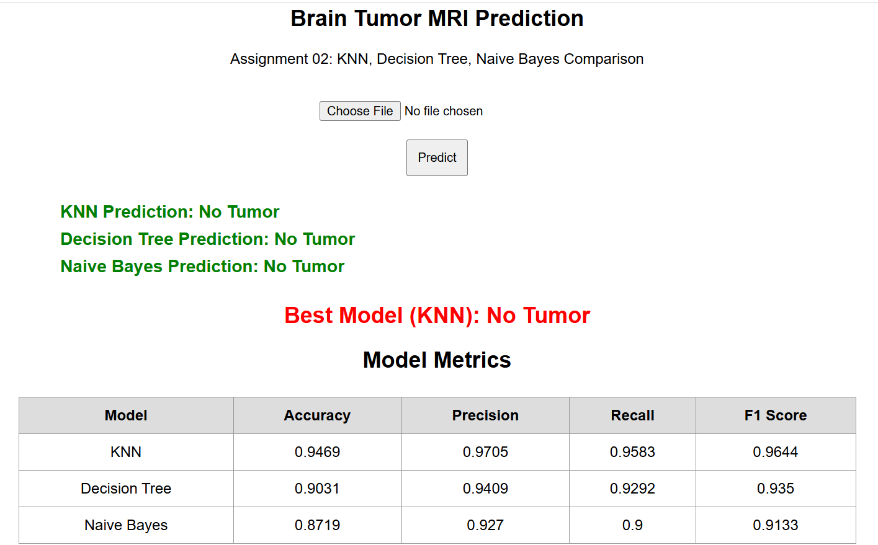

Figure 2: Confusion Matrices
In this figure, the confusion matrices of all three models are displayed. These matrices show the number of correct and incorrect predictions made by each model. It also includes the best parameters used for each model, giving a deeper understanding of their performance.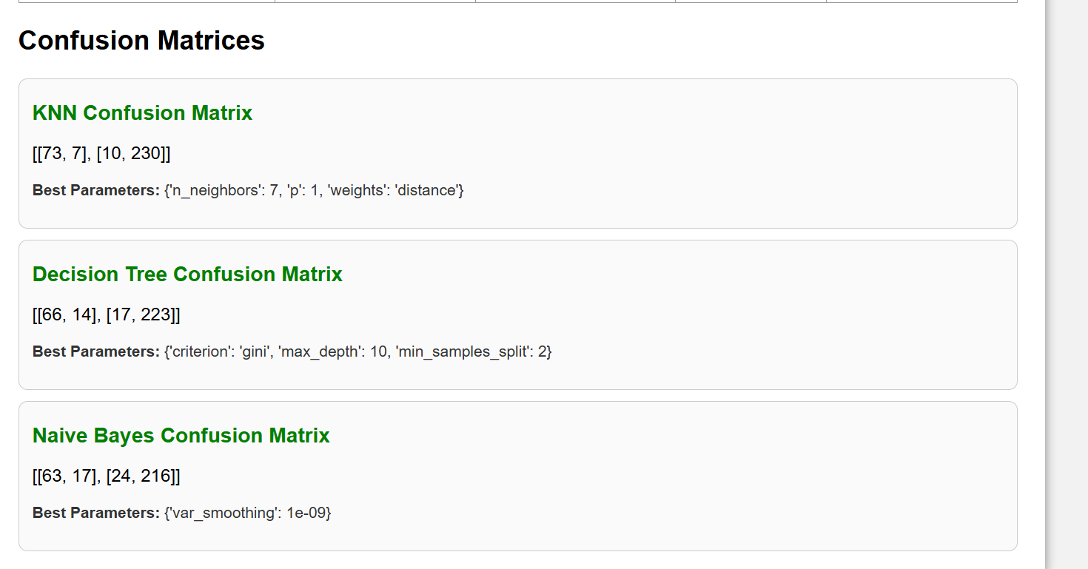

11. Conclusion
This project successfully demonstrates how machine learning can be used for medical image classification. By comparing different models, it becomes easier to select the most suitable one for the task. Among the models used, KNN achieved the highest performance.

